**EXPERIMENT 10 Date: 7th April 2023**

**TITLE:** **Joins in SQL**

**AIM:** To execute and verify the SQL commands using Join.

**OBJECTIVE:** SQL joins are used to query data from two or more tables, based on a relationship between certain columns in these tables.

**Write SQL Queries using Join for the following queries.**

1. **List the details of the emps whose Salaries more than the employee BLAKE.**

SELECT e1.* FROM Emp e1 INNER JOIN Emp e2

ON e2.ename = "Blake" WHERE e1.sal > e2.sal;

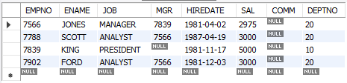

1. **List the emps whose Jobs are same as ALLEN.**

SELECT e1.ename FROM Emp e1 INNER JOIN Emp e2

ON e1.job = e2.job WHERE e2.ename = "Allen";

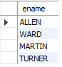

1. **List the Emps whose Sal is same as FORD or SMITH in DESC order of Names.**

SELECT e1.ename FROM Emp e1 INNER JOIN Emp e2

ON e1.sal = e2.sal WHERE e1.ename = "Ford"

OR e2.ename = "Smith" ORDER BY e1.ename DESC;

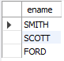

1. **List the emps Whose Jobs are same as MILLER or Sal is more than ALLEN.**

SELECT e1.ename FROM Emp e1 INNER JOIN Emp e2

ON e1.job = e2.job WHERE e2.ename = "Miller"

UNION SELECT e3.ename FROM Emp e3 INNER JOIN

Emp e4 ON e3.sal > e4.sal WHERE e4.ename = "Allen";

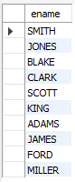

1. **Find the highest paid employee of sales department.**

SELECT e2.ename, e2.sal FROM Emp e2 INNER JOIN

(SELECT MAX(sal) AS M, e1.deptno AS D

FROM Emp e1 INNER JOIN Dept d1 ON

e1.deptno = d1.deptno WHERE d1.dname = "Sales" GROUP BY D)

AS tab1 ON e2.deptno = tab1.D WHERE e2.sal = tab1.M;



1. **List the employees who are senior to most recently hired employee working under king.**

SELECT e1.ename FROM Emp e1 INNER JOIN

(SELECT MAX(e2.hiredate) AS MaxH FROM Emp e2

INNER JOIN Emp e3 ON e2.mgr =

e3.empno WHERE e3.ename = "King")

AS tab ON e1.hiredate < tab.MaxH;

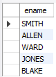

1. **List the names of the emps who are getting the highest sal dept wise.**

SELECT e1.ename, e1.sal, e1.deptno FROM Emp e1

INNER JOIN (SELECT MAX(e2.sal) AS MaxSal, e2.deptno

FROM Emp e2 GROUP BY e2.deptno) AS tab

ON e1.sal = tab.MaxSal;

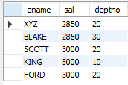

1. **List the emps whose sal is equal to the average of max and minimum**

SELECT e1.* FROM Emp e1 INNER JOIN

(SELECT (MAX(sal) + MIN(sal) ) / 2 AS S

FROM Emp) AS e2 ON e1.sal = e2.S;



1. **List the emps who joined in the company on the same date.**

SELECT e1.* FROM Emp e1 INNER JOIN

Emp e2 ON e1.hiredate = e2.hiredate

WHERE e1.ename != e2.ename;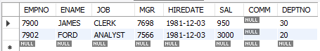

1. **Find out the emps who joined in the company before their managers.**

SELECT e1.ename FROM Emp e1 INNER

JOIN Emp e2 ON e1.mgr = e2.empno

WHERE e1.hiredate < e2.hiredate;

